Leonardo Corso
DBGuard
User manual
Leonardo Corso
5-11-2026

What is DBGuard?
DBGuard (Database Guard) is an application that periodically checks the state of your databases and sends notifications when specific conditions are met. It is useful for catching bad or unexpected data that could cause applications to crash, or for alerting a team when data meets any criteria that warrants attention.
DBGuard supports multiple database engines including SQL Server, PostgreSQL, SQLite, and MySQL.
Monitoring is performed through Guards — each Guard runs a user-defined SQL query on a periodic schedule and compares the result to a user-defined expression. Because the core logic is written in SQL, the application remains decoupled and straightforward to configure.
When a Guard's expression evaluates to true, it can trigger zero or more notifications via SMTP (email) or HTTP (webhooks to other applications or APIs). DBGuard also includes a built-in SPA web application for configuring, testing, and auditing Guards and their execution history.

Getting started

Creating A Guard

Understanding a guard

Guard
A guard is a single query against a single database that evaluates the result to a user defined expression. The guard is created and run at specific intervals as some guards may only need to run once a week, while others multiple times an hour. A guard can be in one of four states:
- Unknown: The initial state of the guard. Indicates the scan has not yet run.
- Error: The guard ran into one of various errors such as it could not connect to the database, the query is invalid, the result column it’s defined to look at does not exist in the result set, or any other error which can occur when a query is ran from a local or remote application against a database.
- Triggered: The user defined query and expression are evaluated as true.
- Clear: The user defined query and expression is not evaluated as true.

Database connection
A database connection is used by the guard to connect to a database. The database connection can be reused by many guards. If the database engine requires a user login, the database user should have only read permission to the database to ensure best security practices. The credentials are encrypted and stored in the application database using an IDataProtector. Some database engines such as SQLite do not use logins so it is not required.

Create a guard
- To create a guard, go to “/guards/view-all” or select “View guards” from the sidebar menu.
- Select the “+Guard” button on the toolbar:

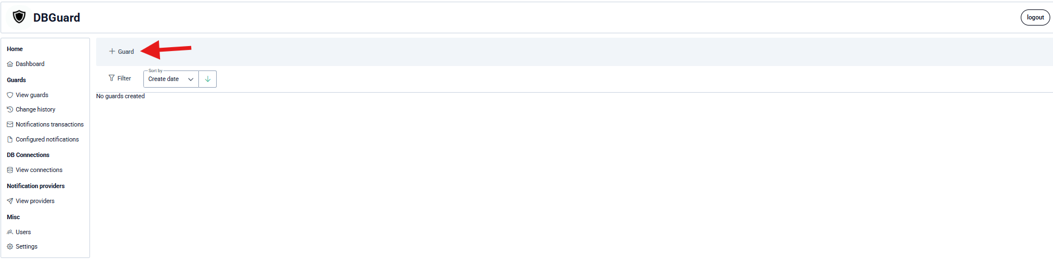
- You will then see the dialog to create the guard:
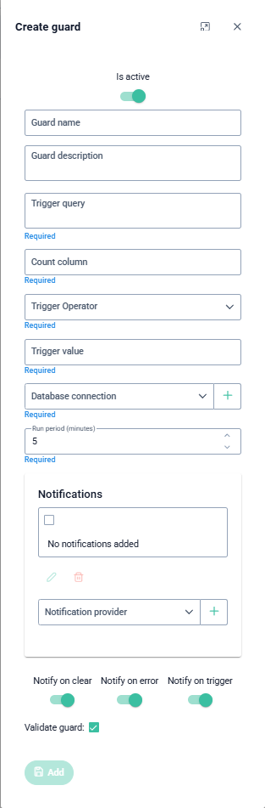
- Here is what each field does:
  - Is active: Boolean that determines if the guard is active or paused and should be run by the monitoring service.
  - Guard name: Optional user-friendly name.
  - Guard description: Optional description of the guard.
  - Trigger query: The SQL query for the guard. The query needs to return a single column and row. The value needs to be an 32bit integer value. The reason for this is that all the logic should be implemented in the query. The application just wants to know the result integer value of your logic so it can decide if it is triggered. You can then configure the guard to trigger when the Count column is greater than one.
  - Count column: This is the name of the column.
  - Trigger operator: The operator for the expression. Supports equals, not equals, greater than, less than, greater than or equal to, less than or equal to.
  - Trigger value: A 32bit integer value for our expression.
  - Database connection: A connection and login if required to our database.
  - Run period: How often should it be run.
  - Notifications: The notifications for the guard.
  - Notify on clear, error, trigger: Whether the guard should notify using its configured notifications when it goes into the clear, error, or triggered state respectively.
  - Validate guard: Whether to validate the guard before creation to ensure it can connect to the database, the query is valid and count column exists in the result set. Will return an error with failure if it is invalid.
- Click add.

Example guard
For example, let’s say we want to be notified once a day if there are any customers in our database who have a debt that is more than $10.50. This is a good example to show that although the guard value is a 32bit integer, it can support monitoring decimals, dates, strings and many other data types since the logic is stored in the SQL query, and the application simply checks a sentinel value.
- Our trigger query may look something like this:
SELECT COUNT(*) as Count
FROM customer_debt
WHERE customer_debt.dollars > 10.5;
- The column we want to look at is called “Count” so the Count column will be “Count”.
- Since the query uses “>” our guard operator will be greater than or equal to.
- Lastly the trigger value will be 1 since we want to be notified if any exist.
- The expression will then read as, trigger guard when “Count” in query is greater than 1.
- Since we want it to run once a day, we will set the run period in minutes to 1440 so it runs every day.
